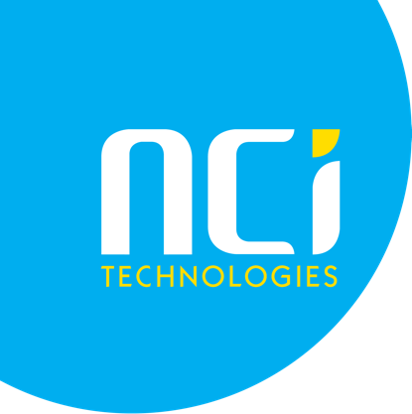

Title: Senior IT Technician
Salary: £28,000 - £40,000 (plus an on call allowance)
Duration: Permanent Post
Location: Remote working and trips to office in Cornwall
We are looking for a seasoned technician with proven experience supporting Microsoft Networks and Microsoft Cloud Services. Your work will include both technical support and project work covering an interesting and wide-ranging list of products and services.
The role will include a mixture of office based, home working and working at customer premises so you must have a valid UK Driving license.
To be successful in this role you will have experience with some or all the following:
- Microsoft Server Operating Systems & Windows Desktop
- Microsoft-Office 365
- Experience working with Firewalls and TCP/IP Networking
- Virtualisation - Hyper-V
- Use of common backup and disaster recovery software
- Switching and WiFi knowledge. Other valuable skills include IP Telephony / SIP / 3CX / Microsoft Teams – Direct Routing
Any experience with the following would be an advantage:
- Endpoint security products / Intune
- Microsoft Azure
- Dell SANs and Storage
- Hyper-V Cluster
- Sonicwall / Unifi
- PSA and RMM Software Tools
Regardless of your technical skills you must have/be:
- Strong communications skills are key and an ability to talk with customers at all levels with a good clear and friendly telephone manner.
- Reliable and able to work both with and without guidance.
- Able to explain issues and deal with customers with varying technical skills.
- Flexible and willing to learn new skills and share knowledge and mentor other technicians.
Training provided and requirement to follow the Microsoft MCP Syllabus and complete at least 1 MCP Exam per year. NCI Technologies will cover the cost of the exams and training material.
Please send your CV with a covering letter to careers@ncitech.co.uk.

